Academic Year: 2025-26 | Year: Second Year | Semester: II
PRN No.: 1012411011 | Name: Riddhee Kulkarni
Subject: Python Programming
Assignment No.: 13
Date: 12/01/2026

Lab Assignment: 13
Aim:
Write a program to calculate the value of an investment. Consider an Initial value and annual interest as an input and calculate the value of the investment over time.

Objective:
• To understand the concept of investment and interest
• To use loop for repeated calculation
• To calculate investment value over time

Theory:
Investment value increases over time due to interest.
The annual interest rate is applied every year to the current investment value.
Using a loop, the investment value is updated year by year and displayed.
Formula used:
Investment Value = Investment Value + (Investment Value × Interest Rate / 100)

Algorithm:
- Start
- Read initial investment amount
- Read annual interest rate
- Read number of years
- Set investment value equal to initial amount
- Repeat for each year
  - Calculate interest
  - Add interest to investment value
  - Round the value up to 3 decimals
  - Display the value
- Stop

Pseudo Code:
START
READ amount
READ rate
READ years
value = amount
FOR i = 1 TO years
value = value + (value * rate / 100)
value = round(value, 3)
PRINT value
END FOR
STOP

Code:
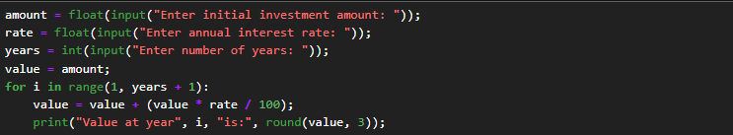

Output:
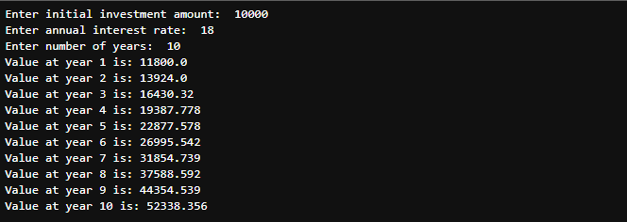

Conclusion:
The program successfully calculates the investment value over time and displays the result rounded up to three decimal places using loops and arithmetic operations.

